**Weathering the Charge: Analyzing the Impact of Weather on EV Charging Station Usage**

**By Matthew Latondresse**

**Business Problem**

As electric vehicles (EVs) become more prevalent, understanding how weather influences the usage of charging stations can help infrastructure planners optimize their placement and availability. This study explores whether certain weather conditions correlate with increased or decreased usage of EV charging stations. Accurately predicting these patterns can ensure that EV infrastructure meets demand, enhancing user experience and supporting the transition to sustainable transportation.

**Background/History**

Electric vehicles are gaining traction as a sustainable mode of transportation, driven by advancements in technology, environmental concerns, and government policies promoting green energy. The effectiveness and efficiency of EV infrastructure, particularly charging stations, are critical for the widespread adoption of EVs. Historically, the placement and availability of charging stations have been based on factors such as population density and driving patterns. However, weather conditions are hypothesized to impact the usage patterns of these stations, potentially influencing the planning and management of EV infrastructure in urban areas. I. Koncar and I. S. Bayram’ study employs probabilistic modeling and Monte Carlo simulations to quantify the impact of cold weather on electric vehicle (EV) demand in the U.K. It finds that cold weather significantly increases the energy and power demands of EVs due to the need for battery and cabin heating. The simulations reveal an additional peak power requirement of 630 MW under cold conditions compared to optimal temperatures. The study also highlights that increased EV demand during cold weather can raise the carbon intensity of the power grid by up to 25% during low renewable generation periods.

**Data Explanation**

**Data Preparation:**

* **Electric Vehicle Charging Station Data:** This dataset includes locations and usage logs of EV charging stations, sourced from municipal transport agencies or open government data portals.
* **Weather Data:** Historical weather data for the same locations and periods, obtained from the National Oceanic and Atmospheric Administration (NOAA).

**Data Dictionary:**

* **EV Charging Station Data:**
  + **station_id:** Unique identifier for each charging station.
  + **location:** Geographical coordinates of the charging station.
  + **time_of_usage:** Timestamp of when the charging station was used.
  + **duration_of_usage:** Duration for which the charging station was used.
  + **user_id:** Anonymized identifier for the user.
* **Weather Data:**
  + **date:** Date of the weather observation.
  + **temperature:** Average temperature for the day.
  + **precipitation:** Amount of precipitation for the day.
  + **humidity:** Average humidity for the day.
  + **wind_speed:** Average wind speed for the day.
  + **weather_conditions:** Description of the weather (e.g., sunny, rainy, snowy).

**Methods**

**Descriptive Statistics:** Summarize the usage patterns and weather conditions using measures such as mean, median, and standard deviation. Visualizations such as histograms and box plots can provide insights into the distribution of data. 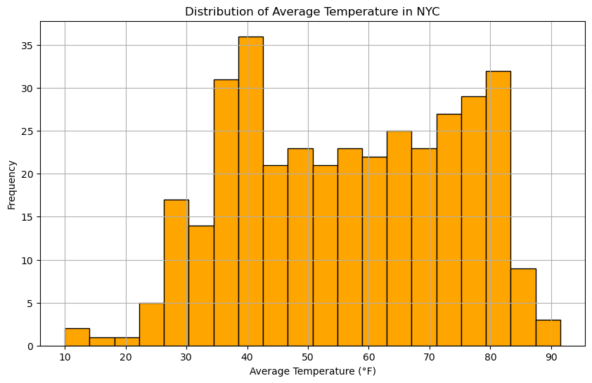

**Correlation Analysis:** Identify relationships between weather variables (like temperature and precipitation) and charging station usage using correlation coefficients. This helps in understanding how weather factors are related to usage patterns.

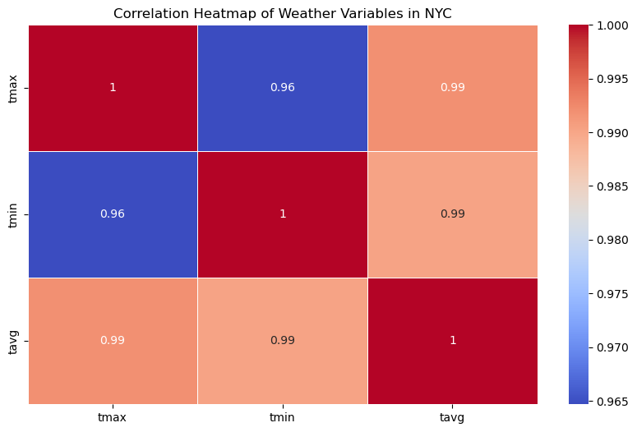

**Regression Analysis:** Develop regression models to quantify the impact of various weather conditions on EV charging station usage. This includes:

* **Time Series Analysis (ARIMA/SARIMA):** To forecast future usage patterns based on historical data, considering seasonality and trends.

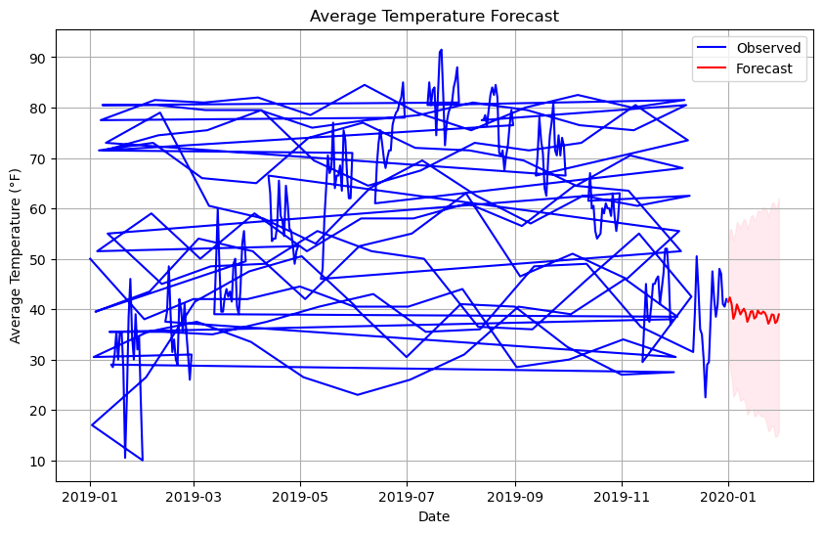

**Analysis**

Preliminary analysis indicates potential correlations between weather conditions and EV charging station usage. For instance, extreme weather conditions (high temperature, heavy rain, or snow) may lead to decreased usage due to unfavorable driving conditions. Descriptive statistics show that usage is higher on mild weather days, while correlation analysis reveals a negative correlation between precipitation and usage.

**Example Findings:**

* **Temperature:** Moderate temperatures (50-70°F) show higher usage, while extremely hot or cold days see a decline.
* **Precipitation:** Rainy and snowy days have lower usage compared to dry days.
* **Humidity and Wind Speed:** Less significant in influencing usage patterns compared to temperature and precipitation.

**Conclusion**

Understanding the relationship between weather and EV charging station usage can aid in optimizing infrastructure placement and availability. Accurate prediction models can ensure that EV drivers have reliable access to charging stations regardless of weather conditions. This supports the overall goal of promoting sustainable transportation and enhancing user experience.

**Assumptions**

* **EV usage patterns are influenced by weather conditions:** It is assumed that weather conditions significantly affect user behavior in terms of charging their vehicles.
* **Data accuracy:** It is assumed that data from municipal transport agencies and NOAA is accurate and comprehensive.
* **Behavioral consistency:** It is assumed that historical usage patterns can predict future behavior, assuming no significant changes in user demographics or technology.

**Limitations**

* **Data Quality:** Ensuring completeness and accuracy, especially for less-monitored charging stations, is a challenge. Missing data or inaccuracies can impact the analysis.
* **Correlation vs. Causation:** Differentiating correlation from causation in weather impacts on EV charging station usage is complex. Other factors not accounted for in the model might influence usage.
* **Temporal Coverage:** Limited historical data can affect the robustness of the models, especially for capturing long-term trends.

**Challenges**

* **Data Integration:** Combining data from various sources and ensuring consistency is challenging. Different formats and timeframes require careful alignment.
* **Data Privacy:** Protecting personal information related to charging station usage is crucial. Anonymization techniques must be robust to prevent re-identification.
* **Model Complexity:** Developing models that accurately capture the relationship between weather and usage requires advanced statistical techniques and significant computational resources.

**Future Uses/Additional Applications**

* **Urban Planning:** Use insights to inform the development of resilient EV infrastructure, ensuring stations are placed in optimal locations considering weather patterns.
* **Policy Making:** Guide policy decisions on sustainable transportation and urban development, promoting infrastructure that supports EV adoption.
* **Real-time Applications:** Implement real-time usage prediction models to dynamically manage charging station availability and maintenance.

**Recommendations**

* **Data Collection:** Enhance the monitoring and maintenance of EV charging stations to ensure high-quality data. This includes automated data collection systems and regular audits.
* **Infrastructure Development:** Consider weather patterns in the planning and placement of EV charging stations. Ensure that stations are resilient to extreme weather conditions.
* **User Awareness:** Educate users about the impact of weather on charging station availability and encourage proactive planning for charging needs.

**Implementation Plan**

**Phase 1:** Collect and preprocess data from identified sources. This involves cleaning the data, handling missing values, and ensuring consistency.

**Phase 2:** Conduct descriptive and correlation analysis to identify key relationships. Use visualizations to communicate findings.

**Phase 3:** Develop and validate regression models to predict usage patterns. This includes training and testing models and refining them based on performance metrics.

**Phase 4:** Implement findings in infrastructure planning and policy recommendations. Collaborate with urban planners and policymakers to integrate insights into decision-making processes.

**Ethical Assessment**

* **Privacy Concerns:** Ensure anonymization of data to protect user identities. Use techniques like data masking and aggregation to prevent re-identification.
* **Data Misinterpretation:** Avoid misinterpretation that could lead to poor planning and investment. Clearly communicate the limitations and assumptions of the models.
* **Transparency:** Maintain transparency in data collection, analysis, and reporting processes. Ensure that stakeholders understand how conclusions were drawn and the implications of the findings.

**Questions**

* **What motivated this study on the impact of cold weather on EV demand?**

The motivation stems from the increasing adoption of EVs and the need to understand how cold weather affects their energy consumption and charging patterns, which is crucial for efficient grid management and infrastructure planning.

* **How does cold weather affect the performance of EV batteries?**

Cold weather reduces the energy efficiency of lithium-ion batteries, requiring more energy for heating the battery and cabin, which decreases the driving range and increases the frequency of charging.

* **What is the Monte Carlo simulation, and why was it used in this study?**

The Monte Carlo simulation is a statistical method that uses random sampling to estimate complex systems. It was used to model and analyze the probabilistic impacts of various weather conditions on EV demand.

* **How significant is the increase in energy demand due to cold weather for EVs?**

The study found that cold weather necessitates an additional 630 MW of peak power compared to optimal temperatures, highlighting a substantial increase in energy demand.

* **What are the implications of increased EV demand on the power grid during cold weather?**

Increased EV demand during cold weather can strain the power grid, leading to potential supply shortages and increased carbon intensity due to the reliance on carbon-intensive backup generators.

* **What are some mitigation strategies proposed by the study to handle the increased EV demand?**

The study suggests using on-site energy storage at charging stations, implementing pricing-based policies to defer charging to off-peak hours, and employing smart heating and driving applications to reduce energy consumption.

* **How does the study address regional variations in EV demand and weather conditions?**

The study includes regional analysis, considering differences in vehicle ownership, weather patterns, and charging behaviors across various regions in the U.K. to provide a comprehensive understanding of the impact.

* **What data sources were used for the study?**

Data sources included National Grid's Future Energy Scenarios, U.K. regional vehicle statistics, weather data from the Centre for Environmental Data Analysis, and travel surveys from the U.K. and Scottish governments.

* **What are the study's limitations?**

Limitations include focusing only on light-duty vehicles, using three-year average weather data, potential inaccuracies in travel survey data, and not accounting for future advancements in battery technology.

* **How can this study inform future EV infrastructure planning?**

The findings provide critical insights for power system planning, highlighting the need for resilient EV infrastructure that accounts for weather impacts, and guiding policymakers in developing strategies to support sustainable EV adoption.

Reference

*Electric vehicle charging stations in New York*. State of New York. (n.d.). <https://data.ny.gov/Energy-Environment/Electric-Vehicle-Charging-Stations-in-New-York/7rrd-248n/data>

I. Koncar and I. S. Bayram, "A Probabilistic Methodology to Quantify the Impacts of Cold Weather on Electric Vehicle Demand: A Case Study in the U.K.," in IEEE Access, vol. 9, pp. 88205-88216, 2021, doi: 10.1109/ACCESS.2021.3090534.

Moth. (2022, August 17). *New York City Weather Data 2019*. Kaggle. <https://www.kaggle.com/datasets/alejopaullier/new-york-city-weather-data-2019>